**SSH to your AWS Workstation**

**ssh devops@<public-ip-addr**> of your Workstation  
Password is : **Dev0p$!!/**

**Replace <your-name> with your name throughout the lab.**

In order to access the application from outside the App needs to be exposed by using one of the following methods.

1. NodePort.
2. Ingress
3. LoadBalancer

**Exposing Applications using the NodePort.**

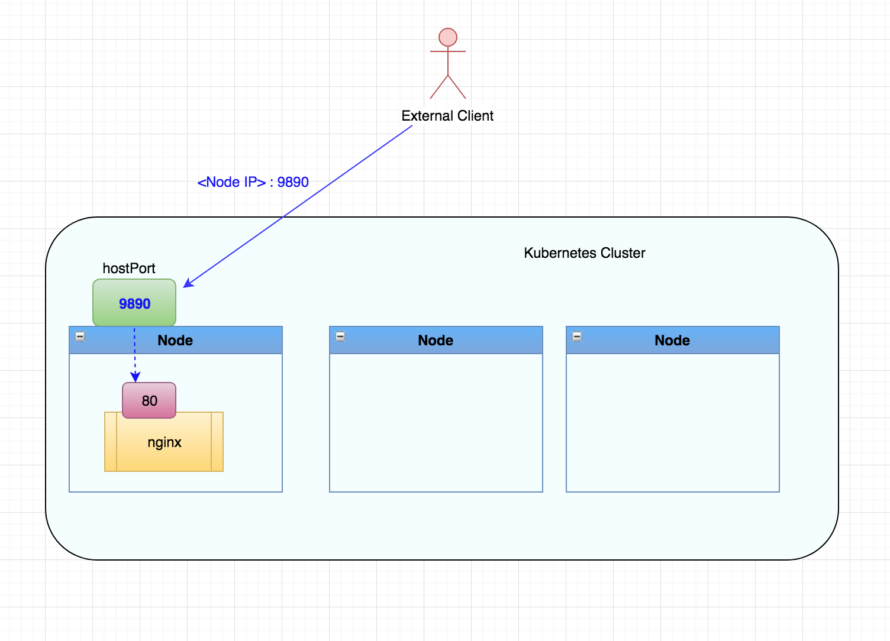

1. Run the below commands.

|  |
| --- |
| $ cd /home/devops/stateless/ $ vim <your-name>-service-nodeport.yaml |

2. Paste the content below in the vim editor.

|  |
| --- |
| apiVersion: v1  kind: Service  metadata:  name: <your-name>-service-node  labels:  app: <your-name>-app  spec:  type: NodePort  ports:  - port: 80  selector:  app: <your-name>-app |

Save and Exit.

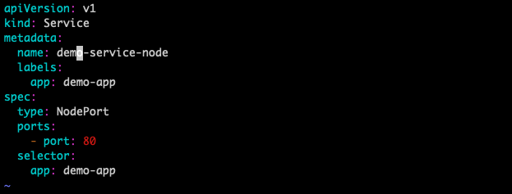

3. Apply and create the Service.

|  |
| --- |
| $ kubectl create -n <your-name> -f <your-name>-service-nodeport.yaml |

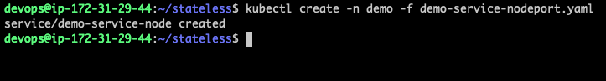

|  |
| --- |
| $ kubectl get svc -n <your-name> |



We can observe that the <your-name>-service-node is exposed as NodePort on Port **31921**

4. Check the NODE where the POD has been deployed.

|  |
| --- |
| $ kubectl get po -o wide -n <your-name> |



In the above screenshot the POD is deployed on Node **gke-pipeline-default-pool-01c11f60-5z5b**

5. Get the PuplicIP of the NODE where is POD is running.

|  |
| --- |
| $ kubectl get nodes -o wide |

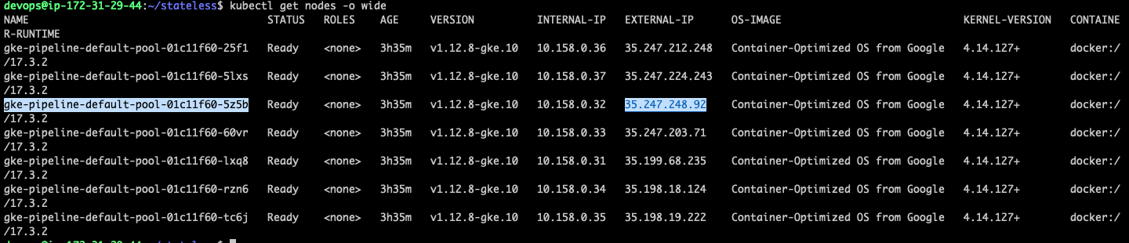

Node Down the External-IP of the Node on which the POD is deployed.

Access the APP using the NODE Public IP and NodePort as shown in the below example.

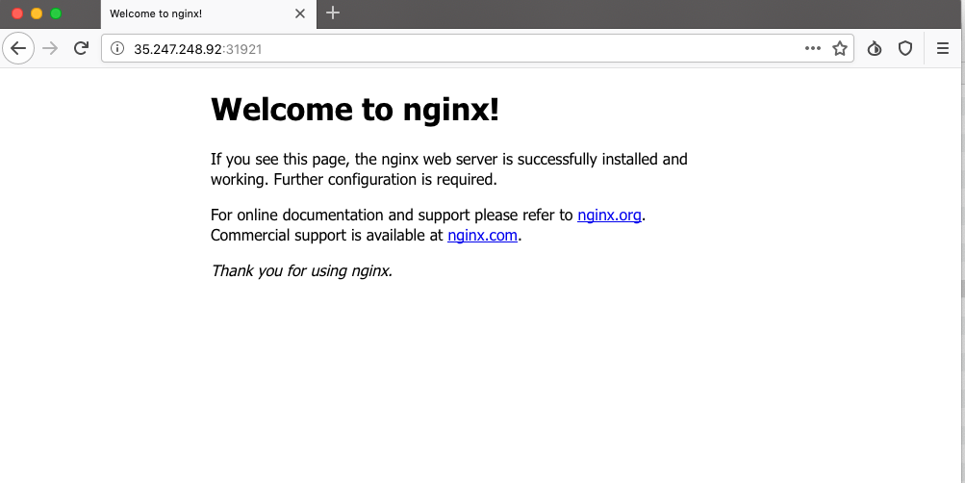

**Clean Up**

|  |
| --- |
| $ kubectl delete deploy/<your-name>-deployment svc/<your-name>-service svc/**<your-name>-service-node** -n <your-name> |

